ChIP-seq analytics, Practical 1
Created by Jun Wang, 2025/2026, CAN7030/130

This practical covers ChIP-seq sequencing read alignment, BAM manipulation, peak calling and peak QC and filtration

(1) First open an X terminal in your computer and login to QMUL HPC Aprocria using ‘SSH’

$ ssh -x username@login.hpc.qmul.ac.uk

This will initiate a two step login into the HPC. First, enter your encryption key, followed by your password.

(2) Copy two fastq files from shared resource directory “/data/teaching/bci_teaching/ChIP_seq”, to your own working directory using ‘cp’

ls /data/teaching/bci_teaching/ChIP_seq

use ‘ls’ to display and list items in your current directory.
Tip: ‘./’ is current directory; ‘../’ is parent directory

Then simply copy the required fastq files from this shared directory to your current working directory. For the sake of good practise, you should make a directory called ‘ChIP-seq’ in your home directory.

pwd (pwd displays your current directory)
mkdir ChIP-seq (mkdir makes a new directory, in this case called ChIP-seq)
cd ChIP-seq (cd goes into the directory, in this case ChIP-seq)

cp /data/teaching/bci_teaching/ChIP_seq/CAPAN1_H3K4me1_chr12.fq ./
cp /data/teaching/bci_teaching/ChIP_seq/CAPAN1_H3K4me3_chr12.fq ./
ls

now you have two fastq files in your current working directory ChIP-seq. One is “CAPAN1_H3K4me1_chr12.fq”, the other is “CAPAN1_H3K4me3_chr12.fq”

Also please copy “CAPAN1_input_chr12.rmdup.bam” into your current working directory, as we will need this BAM for peak calling later

cp /data/teaching/bci_teaching/ChIP_seq/CAPAN1_input_chr12.rmdup.bam ./
ls

(3) Set up qlogin in HPC first

$ qlogin -pe smp 2 -l h_vmem=4G -l h_rt=2:0:0

This qlogin example requests 2 cores of CPU, 4GB of RAM and runtime of 2 hours. But if you have very big jobs in your future work, use ‘qsub’ to put your job into the HPC queue. See HPC document in https://learn.hpc.qmul.ac.uk/. Use your username and password for your HPC login.

If somehow your request could not be scheduled, you can try again later.
You can perform some simply tasks using ‘fontend8’. If you perform heavy tasks and long jobs, your jobs are probably killed by the administrator.

Once you are assigned a node, cd into your working directory

$ cd ~/ChIP-seq/

‘~/’ is a shortcut for you home directory

(4) load Bowtie2 and perform alignment.
Here we practise the alignment to human genome chromosome 12 only. The chromosome 12 bowtie2 index has been pre-built for you, at this directory “/data/teaching/bci_teaching/reference_data”

$ module load bowtie2

$ bowtie2 -p 4 -q --local -x /data/teaching/bci_teaching/reference_data/chr12_hg38_bowtie2 -U CAPAN1_H3K4me1_chr12.fq -S CAPAN1_H3K4me1_chr12.sam &

$ bowtie2 -p 4 -q --local -x /data/teaching/bci_teaching/reference_data/chr12_hg38_bowtie2 -U CAPAN1_H3K4me3_chr12.fq -S CAPAN1_H3K4me3_chr12.sam &

head CAPAN1_H3K4me1_chr12.sam
head CAPAN1_H3K4me3_chr12.sam

Each of the alignment should take ~5 mins to finish, with 4 CPU requested using qlogin.

Note that in the practical, we are practising the alignment of single end reads, but in most of the work now, we will have paired end read sequencing with two fastq files “fastq_1” and “fastq_2” for each sample. We will need to use the Bowtie2 or BWA paired end sequence alignment mode. Please see their manual for more information.

While you are waiting, you could copy the SAM alignment files from “/data/teaching/bci_teaching/ChIP_seq” to your own working directory for the following analysis.

cp /data/teaching/bci_teaching/ChIP_seq/CAPAN1_H3K4me1_chr12.sam ./
cp /data/teaching/bci_teaching/ChIP_seq/CAPAN1_H3K4me3_chr12.sam ./

(5) SAM to BAM conversion and remove PCR duplicates

$ module load samtools

First, convert SAM to BAM format

$ samtools view -S -b CAPAN1_H3K4me1_chr12.sam > CAPAN1_H3K4me1_chr12.bam
$ samtools view -S -b CAPAN1_H3K4me3_chr12.sam > CAPAN1_H3K4me3_chr12.bam

Next, sort these alignments with regard to their position in the reference genome

$ samtools sort CAPAN1_H3K4me1_chr12.bam -o CAPAN1_H3K4me1_chr12.sorted.bam
$ samtools sort CAPAN1_H3K4me3_chr12.bam -o CAPAN1_H3K4me3_chr12.sorted.bam

Remove PCR duplicates

$ samtools rmdup -s CAPAN1_H3K4me1_chr12.sorted.bam CAPAN1_H3K4me1_chr12.rmdup.bam
$ samtools rmdup -s CAPAN1_H3K4me3_chr12.sorted.bam CAPAN1_H3K4me3_chr12.rmdup.bam

You can further look at the basic alignment stats using ‘samtools flagstat’

$ samtools flagstat CAPAN1_H3K4me1_chr12.rmdup.bam
$ samtools flagstat CAPAN1_H3K4me3_chr12.rmdup.bam

We do not need to perform ‘downsampling’ in the exercise.

(6) Peak calling using MACS2

Install MACS2 using miniforge into a new mamba environment

First, load package miniforge
$ module load miniforge

If it says miniforge cannot be loaded, you may need to unload “python/3.11.7-gcc-12.2.0” first using
$ module unload python/3.11.7-gcc-12.2.0
$ module load miniforge

Then you can create macs2 environment to install macs2. Here we create an environment named as “macs2_test”. Here we install macs2 version 2.2.7.1

$ mamba create -n macs2_test python=3.10 macs2=2.2.7.1 -c bioconda

$ mamba create -n macs2_test macs2=2.2.7.1 -c bioconda
$ mamba activate macs2_test

Make an output folder called macs2 using ‘mkdir’ in your “~/ChIP-seq/” folder

$ mkdir macs2
ls

You should have a new folder called ‘macs2’ now in your current directory.

Call peaks using MACS2. Make sure you run the following command in the “~/ChIP-seq/” you created.

$ macs2 callpeak -t CAPAN1_H3K4me1_chr12.rmdup.bam -c CAPAN1_input_chr12.rmdup.bam -f BAM -g 1.3e+8 -B -n CAPAN1_H3K4me1_chr12 --broad --outdir macs2 2>macs2/CAPAN1_H3K4me1_chr12.log &

$ macs2 callpeak -t CAPAN1_H3K4me3_chr12.rmdup.bam -c CAPAN1_input_chr12.rmdup.bam -f BAM -g 1.3e+8 -B -n CAPAN1_H3K4me3_chr12 --broad --outdir macs2 2>macs2/CAPAN1_H3K4me3_chr12.log &

Note: for transcription factors, use narrow peaks (default in MACS2); for histone marks, using broad peaks
’-g 1.3e+8’ is for this example only, size of chromosome 12. For the human whole genome, it should be ’-g 3.0e+9’
The specification ‘-B’ here is to ask MACS2 to generate bedGraph files that can be loaded into genome browsers, such as IGVtools, to inspect the ChIP-seq signals.

See MACS2 manual for more information.
$ macs2 callpeak -h (see the help page of usage and parameters)

Once you finish with MACS2, it is good to deactivate the conda environment.
$ mamba deactivate

You should have output files as follows, using “ls macs2/”

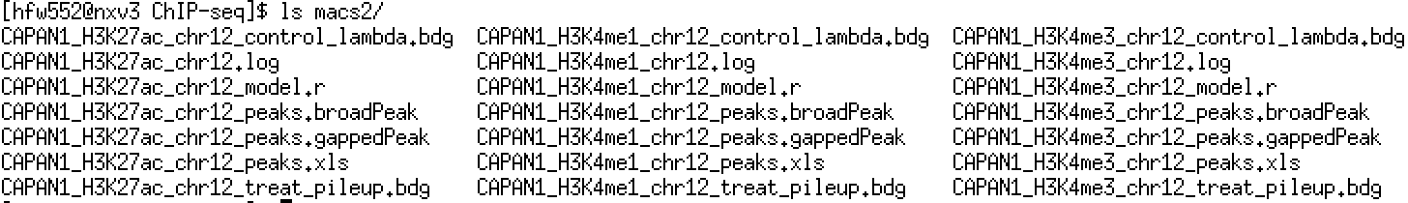

(7) You can further filter the peaks

Download the peak calling files from HPC to your local machine and folder.

In your own computer, open a terminal. And go to a folder you’d like to work in

$ mkdir ChIP_seq_files
$ cd ChIP_seq_files
$ scp username@login.hpc.qmul.ac.uk:/your_working_directory_in_HPC/ChIP-seq/macs2/CAPAN1_H3K4me1_* ./
$ scp username@login.hpc.qmul.ac.uk:/your_working_directory_in_HPC/ChIP-seq/macs2/CAPAN1_H3K4me3_* ./

Here change the directory to your own directory where your store the macs2 output in the HPC.
For example,
$ scp username@login.hpc.qmul.ac.uk:/data/home/btxxxx/ChIP-seq/macs2/CAPAN1_H3K4me1_* ./

$ scp username@login.hpc.qmul.ac.uk:/data/home/username/ChIP-seq/macs2/CAPAN1_H3K4me1_chr12_peaks.broadPeak ./

$ scp username@login.hpc.qmul.ac.uk:/data/home/username/ChIP-seq/macs2/CAPAN1_H3K4me3_chr12_peaks.broadPeak ./

Or you can download them from the shared teaching folder

$ scp username@login.hpc.qmul.ac.uk:/data/teaching/bci_teaching/ChIP_seq/macs2/CAPAN1_H3K4me1_chr12_peaks.broadPeak ./

$ scp username@login.hpc.qmul.ac.uk:/data/teaching/bci_teaching/ChIP_seq/macs2/CAPAN1_H3K4me3_chr12_peaks.broadPeak ./

Also download CAPAN1_H3K27ac peak calling files from HPC to your local folder for later

$ scp username@login.hpc.qmul.ac.uk:/data/teaching/bci_teaching/ChIP_seq/macs2/CAPAN1_H3K27ac_chr12_peaks.broadPeak ./

Open Rstudio

First set your work directory as the directory where you just download these peak calling files to

> setwd("your_working_directory")

For example:
> setwd("/Users/hfw552/Downloads/ChIP_seq_files/")
> getwd()

Read the peak file (broadpeak in this case) into R
> peak_H3K27ac <- read.delim("CAPAN1_H3K27ac_chr12_peaks.broadPeak", header=F)
> View(peak_H3K27ac)
> dim(peak_H3K27ac)
[1] 5783 9
> head(peak_H3K27ac)

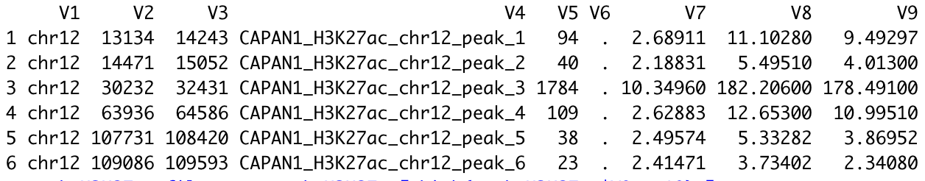

Now filter the peaks using a q value cutoff of “q < 1E-10”

> peak_H3K27ac_filter <- peak_H3K27ac[which(peak_H3K27ac$V9 > 10),]
> dim(peak_H3K27ac_filter)
[1] 1280 9
## after the q value filtering, the number of peaks reduced from 5783 to 1280

> head(peak_H3K27ac_filter)

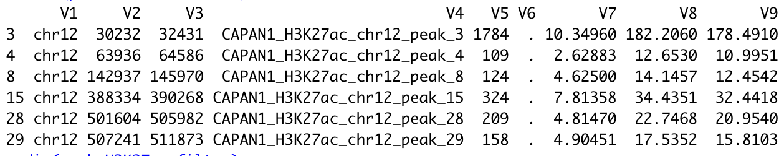

You can then write this into an output file for any downstream analysis

> write.table(peak_H3K27ac_filter, file="CAPAN1_H3K27ac_chr12_peaks.broadPeak_filtered2.bed", quote=F, sep="\t", row.names=F)

You should see this file “CAPAN1_H3K27ac_chr12_peaks.broadPeak_filtered.bed” in your current working directory now.

Before your view this bed file, make sure you remove the first row with the column of “v1 v2….v9”, as IGVtools will confuse with this row if exists.

(8) Use IGVtools to inspect ChIP-seq calling

Open IGVtools, and choose human genome ‘hg38’ to display the genome

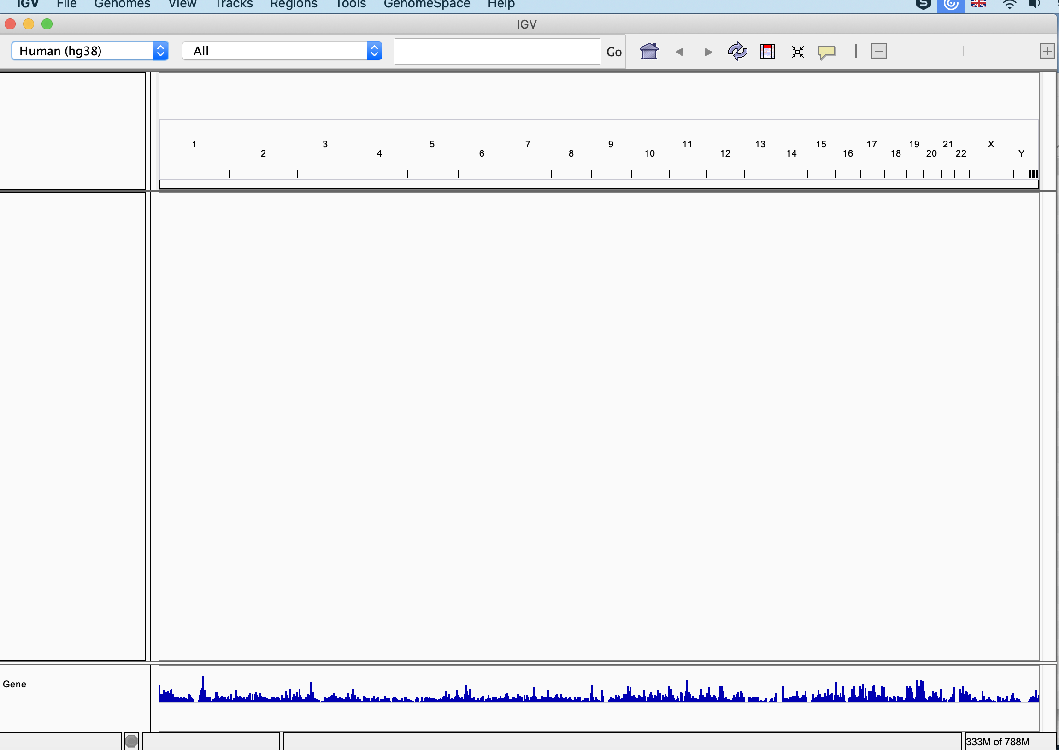

Next, download these .bdg bedGraph files from your HPC ChIP-seq folder macs2 folder to your current working folder

$ scp username@login.hpc.qmul.ac.uk:/data/home/username/ChIP-seq/macs2/CAPAN1_H3K4me1_chr12_treat_pileup.bdg ./
$ scp username@login.hpc.qmul.ac.uk:/data/home/username/ChIP-seq/macs2/CAPAN1_H3K4me1_chr12_control_lambda.bdg ./

$ scp username@login.hpc.qmul.ac.uk:/data/home/username/ChIP-seq/macs2/CAPAN1_H3K4me3_chr12_treat_pileup.bdg ./
$ scp username@login.hpc.qmul.ac.uk:/data/home/username/ChIP-seq/macs2/CAPAN1_H3K4me3_chr12_control_lambda.bdg ./

$ scp username@login.hpc.qmul.ac.uk:/data/teaching/bci_teaching/ChIP_seq/macs2/CAPAN1_H3K27ac_chr12_treat_pileup.bdg ./
$ scp username@login.hpc.qmul.ac.uk:/data/teaching/bci_teaching/ChIP_seq/macs2/CAPAN1_H3K27ac_chr12_control_lambda.bdg ./

drag the .bdg bedGraph files into IGVtools to view the peak calls. Choose hg38 and chr12

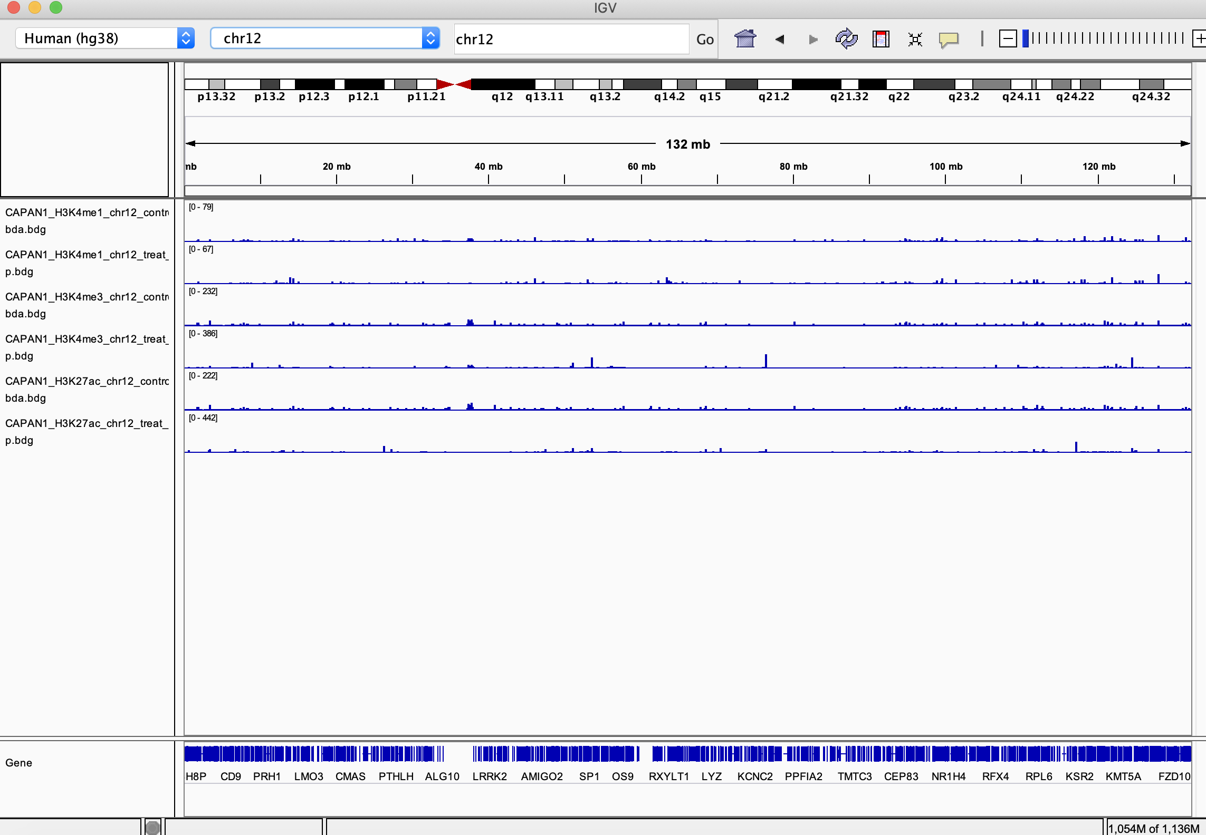

You can right click the tracks and select Autoscale to make the coverage plots look nice
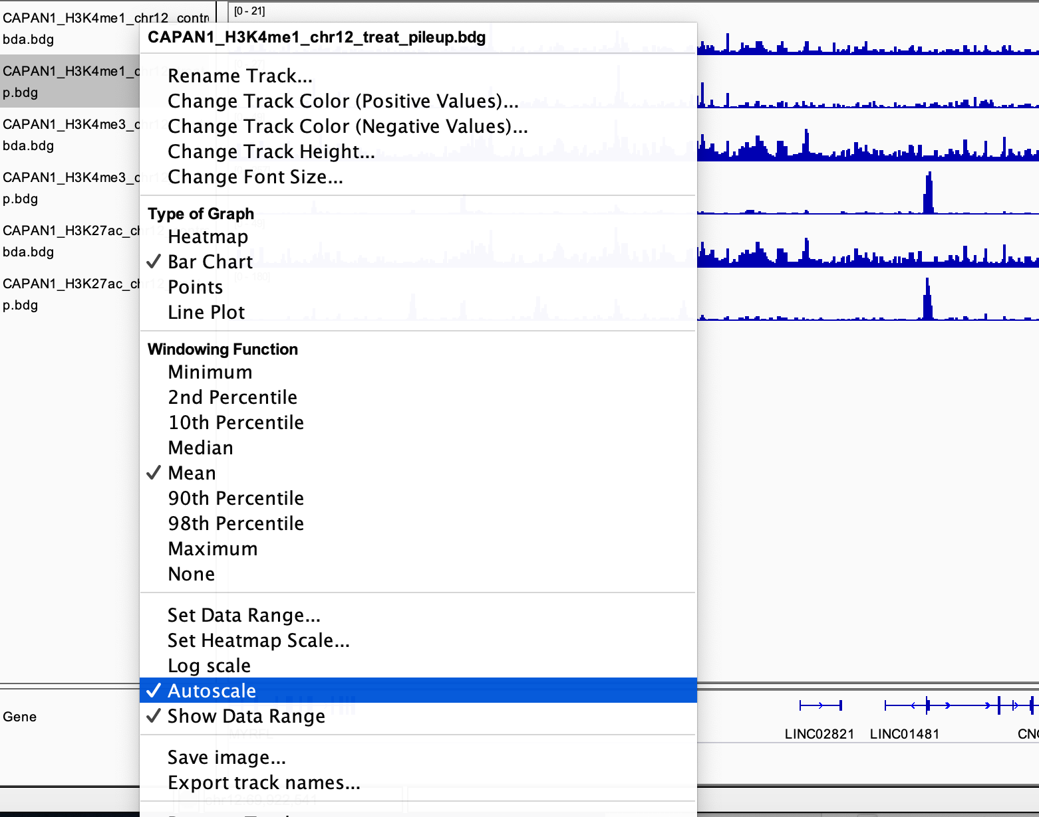

You can further zoom in to look at specific regions and genes

